March 6, 2025

Dear Processor of Recyclable Materials:

The 1988 Maryland Recycling Act (MRA) requires each county in Maryland and Baltimore City to report annually to the Maryland Department of the Environment (the Department) the:

1. Amount and types of materials recycled;
2. Total amount, by weight, of solid waste collected;
3. Total amount, by weight, of solid waste disposed of at solid waste acceptance facilities;
4. Methods of disposal of solid waste used, other than recycling; and
5. Percentage reduction in the amount of solid waste needing disposal that has been achieved.

The *MRA Tonnage Report Form for Processors* is necessary so Maryland Counties and Baltimore City can accurately complete the required report.

All of the materials necessary to complete the *MRA Tonnage Report Form for Processors* are available on-line in the “Processor MRA Reporting Forms” section of the “County Coordinator Resources” page at [www.mde.maryland.gov/recycling](http://www.mde.maryland.gov/recycling). The direct link for the information is<https://mde.maryland.gov/programs/LAND/RecyclingandOperationsprogram/Pages/CountyCoordinatorResources.aspx> The section includes:

* *MRA Tonnage Report Form for Processors* to be completed and **returned to the County where the recyclables originated**;
* *MRA Tonnage Report Form for Processors Guidelines* that contain information regarding completing the report form;
* *Processor Mailing List – 2024* that contains a list of all processors that received this report;
* *Maryland Zip Codes* that contains an alphabetized list of Maryland post offices and the corresponding county to help determine the origin of recyclables collected; and
* *County Recycling Coordinators Contact Information.*

**IT IS IMPORTANT** to refer to the processor guidelines when completing the form to ensure uniform reporting of recyclables across the State.

**DO NOT return completed forms to the MDE**. Report forms should be completed and **returned to the County** (or Baltimore City) where the recyclables originated **by March 24, 2025.** If you have specific questions in completing the report form for a jurisdiction, please contact the appropriate County Recycling Coordinator (see website for the list of County Recycling Coordinators). If you have general questions please contact MDE’s Waste Diversion Division at 800-633-6101 x4142, 410‑537-3314, or [dave.mrgich@maryland.gov](mailto:dave.mrgich@maryland.gov). Thank you in advance for providing the information needed to determine Maryland’s 2024 waste diversion rate.

Sincerely,

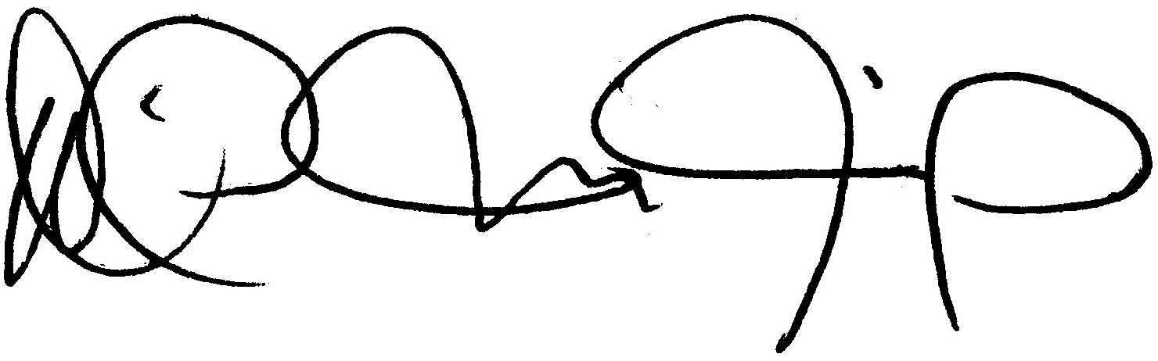

David Mrgich, Chief

Recycling Unit