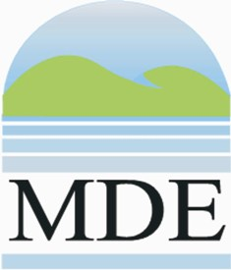
4th annual Clean Water Innovations Trade Show
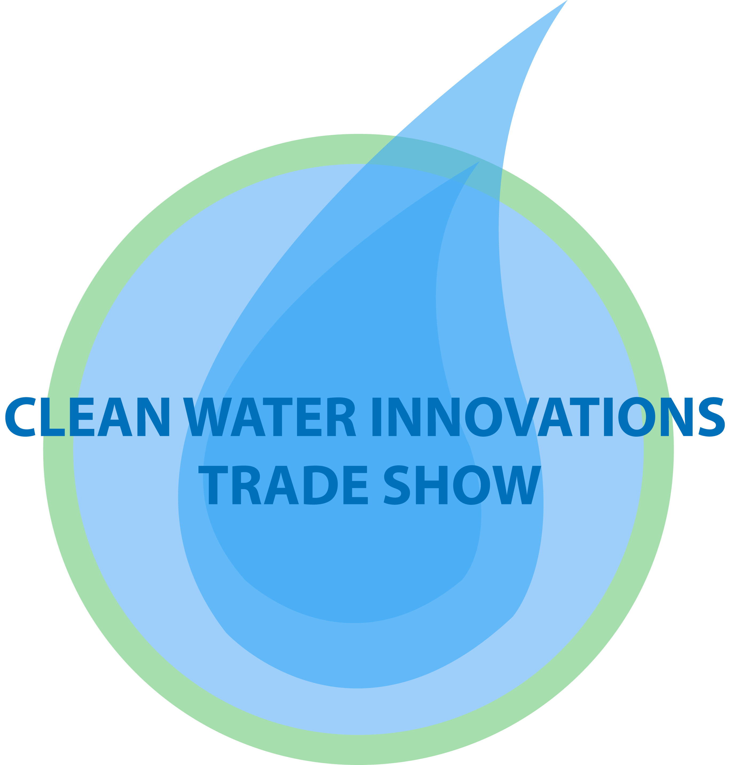
Tuesday, October 21, 2014, 9 a.m. – 3 p.m.
Baltimore, MD

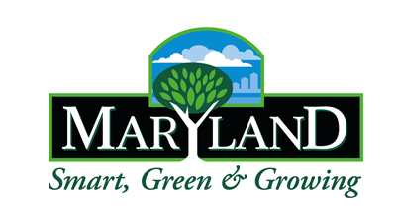
VENDOR REGISTRATION FORM

Please complete the form below and send via email to: adrienne.diaczok@maryland.gov

(There is no cost to participate in this event. Space will be granted in the order your vendor registration form is received. Booth includes 8x8 space with a 6-ft table and two chairs. A continental breakfast will be provided. Sorry, no electrical hookup available at the booths, although facilities will be available to re-charge equipment.)

Organization:

Contact Name:

Phone:

Address:

City:

State:

Zip code:

Email address:

Website:

Number of attendees at your exhibit (Those not staffing exhibit should register as an attendee):

Product Information:
(Please provide a brief description about your product. This information will be used for marketing this event.)

Please use the below address and fax number if you would prefer to mail or fax your registration form (Please note space will be granted in the order forms are received, email is best): Adrienne Diaczok, Maryland Department of the Environment, 1800 Washington Blvd, Baltimore, MD 21230, or fax: 410-537-3936. Questions: 410-537-3172.

Disclaimer: MDE does not endorse any products or services provided by your company for this event.

