Adaptation & Resiliency Working Group Meeting

HYBRID MEETING
Wednesday, August 27, 2025 · 2:00 – 4:00pm

Maryland Department of Natural Resources
580 Taylor Avenue, Annapolis, MD 21401
Room C-1

Meeting link: https://meet.google.com/kkq-zkpq-cas
Or dial: ‪(US) +1 417-567-3154‬ PIN: ‪462 413 664‬#

Chair: Secretary of Natural Resources, Josh Kurtz
Coordinator: Ryland Taylor, ryland.taylor@maryland.gov

Agenda

- Welcome, Introductions, DNR Update 2:00 - 2:05p
Secretary, Josh Kurtz, Department of Natural Resources (DNR) Meeting Call to Order, Roll Call, and Approve Minutes from Aug 27, 2025 meeting.

State Delegate | Del. Dana Stein
The Conservation Fund | Erik Meyers
The Nature Conservancy | Bob Allen
UMD Sea Grant Extension | Fredrika Moser
UMD Environmental Finance Center | Brandy Espinola
MDE | Matthew Rowe ❌
DNR | Anne Hairston-Strang
MDEM | Sara Bender
DNR | Tom Parham
MDH | Clifford Mitchell ❌
MDP | Debbie Herr Cornwell
MDA | Nadya Chehab
MDOT | Allison Gost
DNR | Catherine McCall
MEA | Jenn Aiosa ❌
Commerce | John Papavasiliou ❌
MIA | Bill Fawcett Joy Hatchette ❌

Action: Members approve meeting minutes via vote Approved
Motion by Fredrika Moser
Seconded by Anne Hairston-Strang
Materials: DRAFT Meeting Notes ARWG 5.28.25

- Office of Resilience Update 2:05 - 2:15p
Summer Modelfino, Deputy Chief Resilience Officer will provide an update on the Office of Resilience work over the past year and what’s ongoing for 2025.

Office of Resilience (Summer M. and Mike H.)

Updates to State Resilience Strategy
- Effort out of legislation and EO to accomplish 5 goals
- Main Goal: Propose and prioritize state level actions for key sectors
- 5 Sectors, 3 Focus Areas
- Summary of Strategy - 2, 5, and 10 year recommendations - Big ideas and open questions
- Timeline:
  - November - December 2025 - Design and Finalization process
  - Early 2026 - Launch goal
- Engaged 120 partners - 5 sector work groups - 20+ expert interviews
- Highlights
  - 19 goals, 47 recommendations
    - Each recommendation has an owner and is tagged as 2, 5, or 10 year timeline
    - Each recommendation has notes on budget/cost
    - Each recommendation we will discuss “why this matters”
    - Still determining the most effective way to show the focus areas and hazards addressed by each recommendation
  - Importance of state coordination around resilience funding
  - Great conversation of whole government approach and institutionalizing resilience
  - Important to focus on housing given the priority for Marylanders - noticed housing wasn’t always at forefront when crosswalking state
  - Discussion on local technical assistance
  - Thoughtful and purposeful around coordination around extreme heat
- What’s next? Finish and launch strategy → implementation → report on strategy → update strategy
- Feel free to reach out to Summer with any questions!

Action: Informative Update
Materials: None

- Hughes Center Climate Smart Agriculture Report Presentation 2:15 - 2:45p
Ernie Shea, President of Solutions from the Land, will be presenting on behalf of The University of Maryland Harry R. Hughes Center for Agro-Ecology. The Hughes center has organized the creation of the “Maryland Climate-Smart Agriculture: Roadmap to Resilience”. This report was created in partnership with a team of Maryland farmers, climate and agriculture scientists, state agencies, and nonprofit organization representatives, and was based on farmers’ direct feedback. It aims to provide the farming community, as well as policymakers, with the information necessary to continue to adapt to changing climatic conditions. This report was commissioned in the Maryland Governor’s supplemental 2022 budget to assess how climate change will affect Maryland’s agricultural community. In addition to extensive outreach to the farming community, it was also developed with input from a wide-ranging research review. This report outlines climate-related threats and provides clear, science-based recommendations to help the industry adapt and remain resilient while remaining economically viable.

Harry Hughes Center Climate Smart Agriculture Report

Overview of H.H Center
- Founded in 1999 by former gov. Harry Hughes
- Bridge between agriculture and environment
- Work together to promote practical “win-win” approaches
- 3 focus areas: research, policy analysis, and outreach
- Goal is to listen to primary constituents and figure out how to bring support to their needs - goal is to enable them to manage resource

Maryland Climate-Smart Agriculture Roadmap to Resilence
- Research component: where academic experts were seeing impacts of climate change going forward
- Outreach component: listening sessions and information gathering sessions to listen to people on the land and get an understanding of what they need
- Heard clearly: climate change is real, happening today, impacting agriculture, and is a concern that requires everyone’s attention
- Secured grant, designed process to conduct study, and received funding in 2021 legislative session to carry it out.
- Bottom up, not top down made up of leadership team composed of different partners
- Extensive outreach with the farming community took place over several years going to communities that were affected. Talked to individuals and organizations
- Thanks to the project leadership team

What is climate-smart agriculture?
- A unique term that is accepted and starts the conversation around how are farmers/agriculture affected
- 3 Pillars
  - How can we sustainably intensify production given climate change impacts?
  - Adaptation and Resilience Efforts - climate change is impact ag in MD and farmers need to be more adaptive and resilient.
  - Resilience is effective (ADD FROM SLIDE)
- Don’t start with carbon pollution!

What is the impact on Maryland agriculture?
- More heat, more intense rain events, extreme shifts in weather and temperature disrupting plant and animal growth processes
- Saltwater intrusion is a growing problem that will likely get worse

What producers currently see?
- What are you experiencing?
  - Confirming classic impacts of climate change in agriculture
    - Sea level rise, heat stress, disease, etc.
- What do you need?
  - Financial support, education on practices, etc.

The Report
- 13 recommendations and key messages
- Capstone message: embrace and adopt a climate smart agroforestry plan
- Farming community hearing about carbon and greenhouse gas emissions - there is a section of recommendations talking about evaluating and implementing adaptive management processes
- Integrated Approach: big conversation about renewable energy development - upsides and downsides
- Clear recommendations and appreciation
- Need for investments in early warning systems - anticipate what is coming
- Recognition for more efficient delivery/information exchange
- Each recommendation has a target audience - very appreciative of input and trust that has been earned from the farming public

Closing Comments
- All of the above - this will take multiple partners working together in public private partnership to bring about the outcomes we are seeking - report lays out suggested responsibilities
- Outcomes and where do we go from here
  - Data, tools, facilitation, and recommendations
- This is not a report that was produced, this is a movement that was created!

Questions:
- Is this a public launch event?
  - Yes, that is the plan. Securing statements of support and letters of commitment from the agricultural community
- Where does the federal government that is closely associated with the farming community fit in? How are they engaged and involved?
  - Our collaboration involves them, but there are differing views over terminology. The farming community is comfortable with the term “climate” and so we will keep it and welcome the federal government to the table as we need them. We are prepared to use different terms to “dance around” regulations if need be.
- You mentioned a one stop shop. We have lots of programs and the farmers need a way to find and access them. Where might that be housed?
  - We have identified the need more than the action. It gets back to integrating and collaborating. We will be working with Sec. Atticks in the coming months. We have agents around the state that can work together and make tools available in a more integrated way.

Action: None
Materials: Slides to be presented

- ARWG NextGen Work Discussion 2:45 - 3:15p
Ryland Taylor (DNR) will lead a discussion on ARWG items tagged in NextGen and ask members to vote on which of these we might take on as a priority to work on in 2026.

NextGen Work

- Items that were flagged - you were sent a table last week and would like to discuss an item on the Work Plan.
- Went through the table of who is assigned each task.
- Compiled tasks into deliverables for the next year - not possible to do them all but want to start
- Are there any that anyone wants to champion?
  - Justice Equity Diversity and Inclusion
    - Forming a subgroup of ARWG making sure we are carrying this out and spreading across state agencies.
      - DNR: state has plans that are due in the next year. Might be a good opportunity for ARWG to walk through
      - Frederika Moser:. It is important to keep in mind that the language is integrated into all of the recommendations. It should be clearly stated.
  - Local Government and State Service Delivery
    - Providing a toolkit for opportunities and grants
      - Identified office of resilience as leader
      - Summer: This is on our roadmap so this is something that we will be working on. We can make sure that we have in our plans.
      - Anne: Should we tie this tighter to the review Chesapeake Bay Agreement, particularly because under the Healthy Landscapes goal there is the question of how we get this information out - maybe we can help as a group. There are already dashboards available we can utilize.
      - Catherine: I would love to see ARWG talk about what we do with it. Lots of conversations about how we interpret and improve networks. How do we work more effectively together?
      - Anne: Suggestion from Bay WG - having office hours where we can help match and provide that specialized technical expertise.
      - Sec Kurtz: From CostSmart: How do we reach and plug into resilience. How do we find interconnectivity between agencies to connect with local governments?
    - Include metrics so you can see the type of value for local governments
  - Climate Jobs and Training
    - Mid level training
      - Formation of a temporary subgroup and compiling inventory
      - Can use these as lenses to look at projects and do case studies and overlay as the things we are looking for that builds linkages
    - Early career training
      - Career training and focus on job opportunities into K-12 education and build into stuff that is already in schools
      - Integrating nature based solutions
      - Have also started to expose early education and early career to different environmental jobs
    - Expanding training and Labor
      - Building out apprenticeship
      - Lots of overlap
      - Question/suggestion: how do we move jobs to be greener as opposed to just making green jobs
        - There may be some overlap. We could do a mini session to see
  - Interagency Funding Coordination
    - ARWG could be a platform for this
    - Context has changed some since current federal administration
    - There are some existing groups
    - Question of where the private sources live
    - Need to think about funding in the future at a larger scale. Balance mitigation with adaptation
    - Potential to look globally for funding
      - Blue Bonds in Netherlands, Caribbean, Israel - much different regulations and insurances
      - Bob Allen at TNC: It is tricky stuff and hard to find the right fit. Hard to transplant from one place to another
  - Critical Infrastructure
    - Develop definition guidance for identifying critical infrastructure
    - Critical first step to help whole section move forward
    - Creation of temporary subgroup
      - Allison: We have this on our radar, I can form a subgroup and will lead that in 2026, just need some help. When these recommendations were developed this came from the adaptation framework. Look at the recommendation about what it means. Deliverable might not be exactly like this language.
- These need participation from the group!

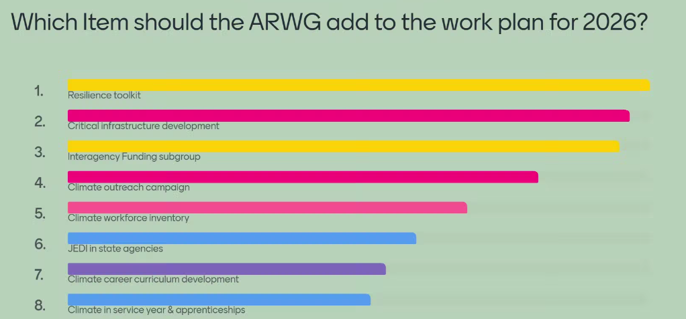
Mentimeter

Action: Informative Update
Materials: None

- ARWG Work Plan Discussion 3:15 - 3:55p
Ryland Taylor (DNR) will lead a discussion on the draft ARWG 2026 work plan.

Workplan
- Next Gen Tracking - development of public tracker, will continue to be a forefront
- Climate and Health Profile Report update -
  - a recommendation that was moved forward into the Commission’s annual report
  - The report should be updated…
  - to facilitate ARWG has begun conveying meetings with appropriate parties.
  - Lots of support
  - Should be convening a meeting soon with universities to see what we already have that should be included
  - Case studies within the application
  - Group will be updated as work progresses
- Strategies for Resilient Coastal Living
  - Different strategies for living in coastal zones
  - Ex; buyouts, elevating homes, community driven moving
  - What is out there, what has worked, and what hasn’t worked
  - Suggestion: Can we add costs and what they are doing
  - Suggestion: Tribal engagement
- Supporting Local Governments
  - Similar to today’s conversation…how do we better serve local governments
  - Devoting a future meeting time discussing best practices and documenting actions to achieve priorities
  - Reaching out to AI and Sec. Kurtz to follow up with DOIT to see if there are people to have a conversation with re: AI disinformation
- Climate Pollution Reduction Grant Money
  - What we are doing with community liaison work. Want to keep those initiatives on the radar
- Other initiatives? Send to Ryland
- Anne: IRA award around resilience - favorite forest practices and enhanced cost share for land owners
- Frederika: Natural capital discussion: link conservation and carbon sequestration management ecosystems as a form of natural capital as opposed to in competition

Link from chat: https://news.un.org/en/story/2025/11/1166351

Second Link from chat: https://dnr.maryland.gov/mdgpi/pages/default.aspx

Action: Members review draft Work Plan provided via email and come prepared to discuss.
Materials: 2026 ARWG Draft Work Plan

- Public Comment, Wrap Up and Next Steps 3:55 - 4:00p

Public Comment:

Jeff Silva:

Problem with Hughes Center for Agro-Ecology slideshow. NO LOSSES QUANTIFIED!
How much money did MD ag lose to wet environment increased blights, rots, disease spread from the last 4 years as compared to a 4 yr. period starting in 2000? How much money did MD ag lose to wet environment increased erosion and runoff from the last 4 years as compared to a 4 yr. period starting in 2000? How much money did MD ag lose to droughts from the last 4 years as compared to a 4 yr. period starting in 2000? How much ag harvest was lost to saltwater intrusion in 2024 as compared to 2000? How much has Maryland crop insurance increased from 2000 as compared to 2024’s insurance premiums?
No points of relevance were provided to the non-agriculture audience!

Next Meeting: February 25, 2026 2-4pm

