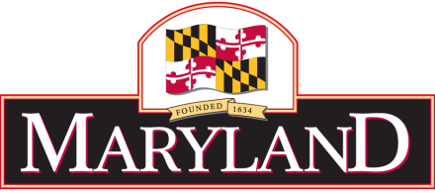

MARINE CONTRACTORS LICENSING BOARD
c/o Maryland Department of the Environment
1800 Washington Blvd., Suite 430, Baltimore, MD 21230
(800) 633-6101, ext. 3249
MARINE CONTRACTORS LICENSING BOARD
Meeting Minutes –February 8, 2021

Location: Virtual Meeting via Google Meet

BOARD MEMBERS PRESENT  Milton Rehbein, Chairman | OTHERS PRESENT  Matthew Standeven, Board Counsel
Tammy Roberson, MDE Rep
Josh Schleupner, Shore Contractor Rep
Douglas Suess, At Large Representative
Robert Murtha, SoMD Contractor Rep
Lester Kelly Wright, DNR Rep

CALL TO ORDER
The meeting was called to order by Mr. Rehbien at 10:00 am using the virtual platform Google Meet. Six Board members were present, as well as the Board’s legal counsel.

AGENDA REVIEW
The Board reviewed and approved the Board’s agenda.

REVIEW OF PRIOR MEETING MINUTES
Board Members reviewed and approved by vote the draft January 2021 meeting minutes.

OLD BUSINESS

- Financial report – sent to board members
- Renewals – renewals are being processed and mailed thru the non-tidal wetland staff
(Note: due to lack of administration at this time, off month renewals are being mailed 3 times a year)
There were 92 Dec. 31 2020 renewals
As of February, there were 11 – non renewals – 9 partial paperwork
- Lengthy discussion on Bill #0333
Board suggestion – local governments and municipalities to be exempt from MCLB license only for maintenance and repairs
- Ivancik approved

NEW BUSINESS

- Discussion on consistency of applications
- Ethic Filing – Do not forget to file by April 2021
- Discussion on appointee exception form
- No requests from board members

ADJOURNMENT
Motion to adjourn by Robert Murtha and seconded by Douglas Suess. The Board voted and approved adjournment at 11:17 AM.

