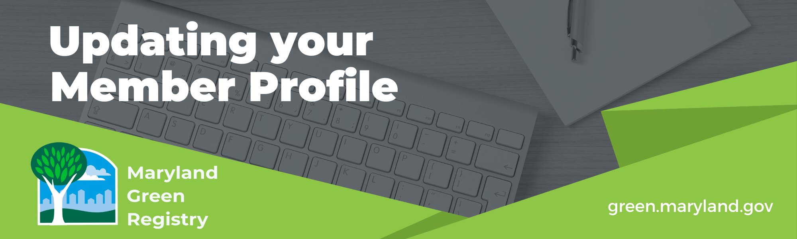

The Maryland Green Registry online member profiles serve as a valuable source of ideas and inspiration. To keep the information current, we ask members to update their profiles whenever they have new sustainable practices or results to share, but no less often than every three years.

To update your profile, 1) e-mail green.registry@maryland.gov to request a copy of your organization’s current profile, 2) edit the Word document with your updates and e-mail it back.

When updating your profile, remember that all profiles must:

- Share information on a minimum of five voluntary environmental practices, and
- Provide a measurable result for at least one of these practices.

The following pages list all the topic areas that members can include in their profiles. To add a new topic area to your profile, just copy and paste the topic heading into your Word document. Don’t worry about formatting. The profiles are cleaned up before being uploaded to the website. If you would like to add a logo to the profile, email it to us as a .png or .jpg file. If you’d like to add a video, please send a weblink.

Thank you for sharing your progress through the Maryland Green Registry!

Note that the topic headings are linked to webpages with tips and resources.

Management and Leadership

Environmental Policy Statement
Please copy or provide a link here (a sample policy and tips can be found on the Maryland Green Registry website):

Environmental Team
Describe your team (membership, mission, how often it meets, etc.) and how it works to identify and implement measures that improve the environmental performance of your facility and operations:

Annual Environmental Goals
Provide an example of specific goals your organization has set to reduce its environmental impact (e.g. reduce solvent use by X%, or reduce greenhouse gas emissions by X% by year 20XX):

Environmentally Preferable Products and Services
Briefly describe the design, composition, packaging and other attributes of the product you produce and/or the service you provide that are designed to reduce environmental impacts:

Environmentally Preferable Purchasing
Describe your procurement policy or approach and provide example(s) of product purchasing decisions or vendor contract language:

Environmental Restoration and Community Environmental Projects
Describe participation or sponsorship of environmental restoration projects (e.g. stream cleanups, enhancement of wildlife habitat, etc.) or community environmental projects or events (outreach to citizen groups, schools, etc.):

Environmental Management System (EMS)
EMSs are a set of procedures that enable organizations to identify and reduce their environmental impacts. Provide the EMS certification standard used by your organization (e.g. ISO 14001, Responsible Care®, Sustainable Green Printing Partnership, etc.):

Aspirational or Long-Term Environmental Goals
Describe the aspirational sustainability goals that your business is actively working toward (e.g. greenhouse gas emissions planning and reporting, Net Zero Energy, Zero Waste, etc.) that extend beyond the annual goals shared above.

Waste

Solid Waste Reduction and Reuse
Describe actions and include results (e.g. lbs. of materials or waste reduced or reused) and cost savings where available:
Recycling
List materials recycled by your facility and quantities (e.g. lbs.) and cost savings where available:

Composting
List organic materials composted by your facility (e.g. food waste or yard waste) and quantities (e.g. lbs) and cost savings where available:

Hazardous Waste/Toxic Use Reduction
Describe voluntary actions and include results (e.g. lbs. of hazardous waste eliminated, or lbs. of toxic material use reduced) and costs savings where available:
Energy

Energy Efficiency
Describe measures taken to improve the energy efficiency of your facility and/or processes and include results (e.g. kWh or BTUs reduced) and costs savings where available:

Renewable Energy
Describe renewable energy systems installed at your facility and include results (e.g. kWh generated) and cost savings where available. Also share if you have purchased renewable energy certificates (RECs) through an independent retailer or by purchasing green power through your utility and include the amount (e.g. kWh) or percentage where available:

Building Electrification

Describe energy efficient electric building technologies installed at your facility (e.g. air source heat pumps, geothermal heat pumps, induction cooktops/stoves, high efficiency electric or heat pump water heaters and other products) and the resulting reduction in fossil fuel use and cost savings where available.

Transportation

Employee Commute/Customer Travel
Describe measures taken to reduce the number and length of employee and/or customer trips taken by single occupancy vehicles and include results (e.g. reduction in vehicle miles travelled or gallons of fuel reduced) where available.

Efficient Business Travel
Describe measures taken to support efficient business travel through teleconferencing, ridesharing and other means and include results (e.g. reduction in vehicle miles travelled or gallons of fuel reduced) and cost savings where available:

Efficient Fleet Vehicles
Describe purchasing, maintenance and other measures taken to increase fuel efficiency in fleet vehicles and include results (e.g. reduction in vehicle miles travelled or gallons of fuel reduced) and cost savings where available:

Water

Water Conservation
Describe actions taken to reduce water use and include results (e.g. gallons of water conserved) and cost savings where available:

Stormwater Management
Describe voluntary actions to reduce stormwater runoff through landscaping, reduction in paved surfaces and other site design measures.
Describe measures taken to ensure that litter, oil, fertilizers and other pollutants from your property do not end up in storm drains and bodies of water:

Green Building

LEED/Green Globes/Living Building Challenge/International Green Construction Code (IgCC)
Indicate here if your organization owns or leases space in a building that has been certified by one of these programs. For LEED, specify which rating system was used (e.g. New Construction, Existing Buildings, etc.) and which level (Certified, Silver, Gold or Platinum). Please also specify the level achieved for Green Globes and the Living Building Challenge.

Environmental Certification Programs, Awards, and Other Activities

Please share any additional information on environmental activities not covered in the categories above, including membership in environmental certification programs and any environmental awards or recognition received by your organization.
